SOP: Azure VM Image Capture with Compute Gallery (Nginx)
Oct 30, 2026 · @ashutosh

Overview
This SOP captures a running Nginx VM into an Azure Compute Gallery, rolls out three image versions (1.0.0 → 2.0.0 → 3.0.0), keeps only the newest marked as latest, and ends with a CLI command that always builds a VM from that latest version.
Scope: Linux VM (Ubuntu) serving /var/www/html/index.html through Nginx, all steps in the Azure Portal (portal.azure.com), plus one Azure CLI command at the end to build a VM from the latest image.
How "latest" works in Azure: when a VM is created from an image definition without a version (or with /versions/latest), Azure picks the highest version number whose excludeFromLatest flag is false. This SOP sets that flag (the Exclude from latest checkbox in the portal) on every version so the newest is always the one picked and older ones are never picked by accident.
Why Specialized images: a Specialized image is captured from a running VM without deprovisioning it. The source VM keeps serving traffic, and every VM built from the image boots with the same Nginx config and content. A Generalized image would require waagent -deprovision and az vm generalize, which permanently retires the source VM.
Version | Built from | index.html shows | excludeFromLatest at the end
1.0.0 | Original VM vm-nginx-src | Version 1 page | true
2.0.0 | vm-web-v1 (edited) | Version 2 page | true
3.0.0 | vm-web-v2 (edited) | Version 3 page | false (LATEST)
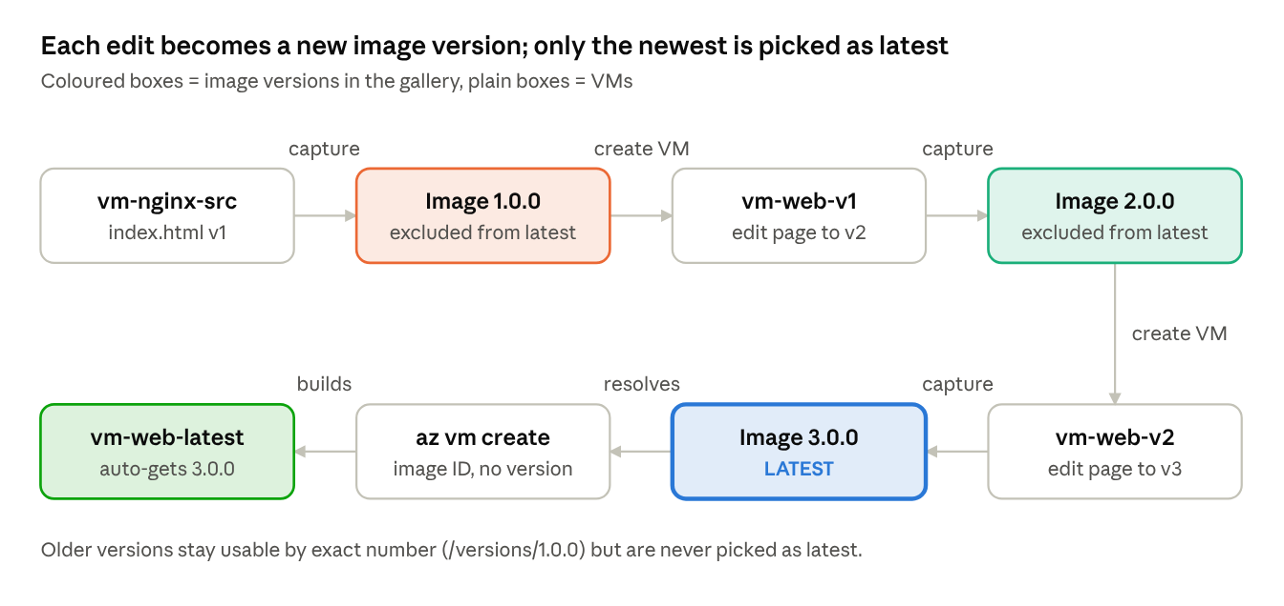
image lifecycle · 3 versions, 1 latest
Each round builds a VM from the previous version, edits the page, and captures the next version; the final az vm create always lands on the newest.

Step 0 · Prerequisites and naming
Use these names throughout (change them to your own), and check the source VM before you start.
Item | Value used in this SOP
Resource group | rg-nginx-images
Region | Central India (same as the source VM)
Source VM | vm-nginx-src
Compute Gallery | galNginxImages
Image definition | nginx-web
Image versions | 1.0.0, 2.0.0, 3.0.0
- ☐ Signed in to portal.azure.com with Contributor rights on the resource group
- ☐ Source VM is Running and http://<public-IP> shows the Nginx page
- ☐ Note the VM's VM generation and Security type: open the VM → Overview → Properties tab (shown as e.g. V2 and Trusted launch). The capture wizard copies these automatically.
- ☐ Inbound port 80 (HTTP) and 22 (SSH) allowed in the VM's network security group

Step 1 · Create the Azure Compute Gallery
The gallery is the container that will hold the image definition and all its versions.
- In the portal search bar, type Azure compute galleries and open it.
- Click + Create.
- Basics tab:
  - Subscription: your subscription
  - Resource group: rg-nginx-images
  - Name: galNginxImages (letters, numbers, dots and underscores only; no hyphens)
  - Region: Central India
  - Description: Nginx web server golden images
- Sharing method tab: keep Role based access control (RBAC).
- Click Review + create → Create.
- When the deployment finishes, click Go to resource.
Checkpoint: the gallery's Overview page opens and shows no image definitions yet. The definition is created in the next step, directly from the capture wizard.

Step 2 · Capture image version 1.0.0 from the source VM
The capture wizard creates the image definition and version 1.0.0 in one pass, while the source VM keeps running.
- Go to Virtual machines → open vm-nginx-src.
- On the Overview toolbar, click Capture (in newer portals: Capture → Image).
- Basics tab, Project details:
  - Resource group: rg-nginx-images
  - Region: Central India
- Share image to Azure compute gallery: select Yes, share it to a gallery as a VM image version.
- Target Azure compute gallery: select galNginxImages.
- Operating system state: select Specialized (the VM is not deprovisioned and keeps running).
- Target VM image definition: click Create new and fill in:
  - VM image definition name: nginx-web
  - Publisher: MyOrg · Offer: NginxWeb · SKU: Ubuntu-Nginx
  - Click OK (VM generation and security type are copied from the VM).
- Version details:
  - Version number: 1.0.0
  - Exclude from latest: leave unchecked (1.0.0 is the only version, so it is latest)
  - End of life date: optional
- Replication: Default replica count 1, target region Central India.
- Storage type: Standard HDD LRS (cheapest for labs) or Premium SSD LRS for production.
- Click Review + create → Create.
Tip: capture takes 10 to 30 minutes. Pause writes on the VM during capture for a consistent snapshot.
Checkpoint: Compute gallery → nginx-web → Versions tab shows 1.0.0 with Provisioning state Succeeded.

Step 3 · Round 1: VM from 1.0.0 → edit index.html → version 2.0.0 (latest)
Build a VM from 1.0.0, change the page, capture it as 2.0.0, then switch 1.0.0 out of "latest".

3.1 Create a VM from version 1.0.0
- Go to Azure compute galleries → galNginxImages → nginx-web → Versions tab → click 1.0.0.
- On the version's toolbar, click + Create VM.
- Basics tab:
  - Resource group: rg-nginx-images · Virtual machine name: vm-web-v1
  - Region: Central India · Size: Standard_B1s
  - Image: already set to nginx-web - 1.0.0
  - Administrator account: greyed out (a Specialized image keeps the original user and SSH key)
  - Public inbound ports: Allow selected ports → HTTP (80) and SSH (22)
- Click Review + create → Create.
- Open the new VM, copy its Public IP address, browse to it: you should see the Version 1 page.

3.2 Update index.html to Version 2
- In vm-web-v1, go to Operations → Run command → RunShellScript.
- Paste the script below and click Run (output appears in about 30 seconds).
cat <<EOF | sudo tee /var/www/html/index.html
<!DOCTYPE html>
<html><head><title>Nginx Image v2</title></head>
<body style="font-family:Arial;background:#0f766e;color:#fff;text-align:center;padding-top:80px">
<h1>Version 2.0.0</h1>
<p>Served from image nginx-web 2.0.0</p>
</body></html>
EOF
sudo nginx -t && sudo systemctl reload nginx
- Refresh http://<vm-web-v1 public IP>: the page is now teal and reads Version 2.0.0.
Prefer SSH? Click Connect → SSH, then run sudo nano /var/www/html/index.html, save, and sudo systemctl reload nginx.

3.3 Capture version 2.0.0 and keep it as latest
- In vm-web-v1, click Capture on the Overview toolbar.
- Fill in as in Step 2, with these differences:
  - Target Azure compute gallery: galNginxImages
  - Operating system state: Specialized
  - Target VM image definition: select the existing nginx-web (do not create new)
  - Version number: 2.0.0
  - Exclude from latest: unchecked
- Click Review + create → Create and wait for Succeeded.

3.4 Remove "latest" from version 1.0.0
- Go to galNginxImages → nginx-web → Versions → click 1.0.0.
- Under Settings, open Configuration.
- Tick Exclude from latest → click Save.
Result: 2.0.0 is latest. 1.0.0 remains usable when chosen by exact version, but is never picked automatically.

Step 4 · Round 2: VM from 2.0.0 → edit index.html → version 3.0.0 (latest)
Same cycle once more; 3.0.0 becomes latest and 2.0.0 is switched out.

4.1 Create a VM from version 2.0.0
- galNginxImages → nginx-web → Versions → click 2.0.0 → + Create VM.
- Virtual machine name: vm-web-v2; everything else as in 3.1 (Standard_B1s, ports 80 and 22).
- Review + create → Create. Browse to its public IP: you should see the teal Version 2 page.

4.2 Update index.html to Version 3
In vm-web-v2 → Operations → Run command → RunShellScript, paste and Run:
cat <<EOF | sudo tee /var/www/html/index.html
<!DOCTYPE html>
<html><head><title>Nginx Image v3</title></head>
<body style="font-family:Arial;background:#7c3aed;color:#fff;text-align:center;padding-top:80px">
<h1>Version 3.0.0</h1>
<p>Served from image nginx-web 3.0.0 (LATEST)</p>
</body></html>
EOF
sudo nginx -t && sudo systemctl reload nginx
Refresh the browser: the page is now purple and reads Version 3.0.0.

4.3 Capture version 3.0.0 and keep it as latest
- In vm-web-v2, click Capture.
- Gallery galNginxImages · OS state Specialized · existing definition nginx-web · Version number 3.0.0 · Exclude from latest unchecked.
- Review + create → Create and wait for Succeeded.

4.4 Remove "latest" from version 2.0.0
- nginx-web → Versions → click 2.0.0 → Settings → Configuration.
- Tick Exclude from latest → Save.
Result: 3.0.0 is latest; 1.0.0 and 2.0.0 are both excluded.

Step 5 · Verify which version is latest
Only 3.0.0 should have Exclude from latest = No.
- Go to galNginxImages → nginx-web → Versions tab.
- If the column is hidden, click Edit columns and add Exclude from latest.
- Compare with the expected view:
Version | Exclude from latest | Provisioning state | Role
3.0.0 | No | Succeeded | LATEST (default pick)
2.0.0 | Yes | Succeeded | Previous, by exact version only
1.0.0 | Yes | Succeeded | Original, by exact version only
If two versions show No, Azure picks the higher number, but set the older one to Yes anyway so the gallery state is unambiguous.

Step 6 · Create a VM that always uses the LATEST image
Point at the image definition, not a version; Azure resolves it to the current latest (3.0.0 today, 4.0.0 after the next round) with no change to the command.

Option A · CLI command (auto-picks latest)
Run in Azure Cloud Shell (the >_ icon in the portal top bar, choose Bash):
IMG_DEF_ID=$(az sig image-definition show \
--resource-group rg-nginx-images \
--gallery-name galNginxImages \
--gallery-image-definition nginx-web \
--query id -o tsv)
az vm create \
--resource-group rg-nginx-images \
--name vm-web-latest \
--image "$IMG_DEF_ID" \
--specialized \
--security-type TrustedLaunch \
--size Standard_B1s \
--public-ip-sku Standard
az vm open-port -g rg-nginx-images -n vm-web-latest --port 80 --priority 1010
# Confirm which version it used (expect 3.0.0)
az vm show -g rg-nginx-images -n vm-web-latest \
--query storageProfile.imageReference.exactVersion -o tsv
Drop --security-type TrustedLaunch if the source VM's Security type was Standard. --image "$IMG_DEF_ID/versions/latest" works the same way.

Option B · Portal (also picks latest)
- Go to galNginxImages → open the nginx-web definition (not a version).
- Click + Create VM on the definition's toolbar; the Image field reads nginx-web - latest.
- Name it, allow ports 80 and 22, Review + create → Create.
- Check the result: VM → Overview → Properties → Image shows the exact version used (3.0.0).

Troubleshooting
Symptom | Likely cause | Fix in the portal
Capture fails with a VM generation mismatch | Existing definition was made for a different generation | Create a new definition from the capture wizard (Create new)
Capture fails with a security type error | Definition lacks Trusted launch | Create a new definition; the wizard copies security type from the VM
Create VM asks for admin username/password | Definition was set to Generalized | Recreate the definition with OS state Specialized
New VM shows an old page | An older version still has Exclude from latest = No | Version → Configuration → tick Exclude from latest → Save
Page not reachable on new VM | Port 80 not open | VM → Networking → Add inbound port rule → HTTP 80
Capture stuck for a long time | Large disk or many replicas | Wait; keep replica count 1 for labs

Rollback and cleanup
Roll back latest to 2.0.0 (nothing deleted):
- Version 3.0.0 → Configuration → tick Exclude from latest → Save.
- Version 2.0.0 → Configuration → untick Exclude from latest → Save.
Delete lab resources (order matters: VMs, then versions, then definition, then gallery):
- Virtual machines → select vm-web-v1, vm-web-v2, vm-web-latest → Delete; tick Delete with VM for OS disk, NIC and public IP.
- galNginxImages → nginx-web → Versions → delete 3.0.0, 2.0.0, 1.0.0.
- galNginxImages → select nginx-web → Delete.
- Open galNginxImages → Delete.
If rg-nginx-images holds only lab resources, deleting the resource group removes everything in one go.

